

**Student Registration Packet**

**Career Exploration and Assessment**

**Project Discovery is located at**

**1420 East College Drive in Marshall, MN.**

** PLEASE RETURN THIS REGISTRATION PRIOR TO ATTENDANCE:

**Project Discovery**

SWWC Service Cooperative

1420 East College Drive

Marshall, MN 56258

Attn: Mary Mortier

Or Email: [mary.mortier@swwc.org](mailto:mary.mortier@swwc.org)

Phone: 507-537-2254

Fax: 507-537-7327

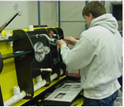



**PROJECT DISCOVERY**

Name:       School:

Project Discovery is located at 1420 East College Drive, Marshall, MN 56258

Choose a total of **five** career units you would like to explore. **Place a (1) by the first choice, a (2) by the second choice, a (3) by the third choice, etc**. Consider all careers. You won’t know if you may be interested in a career unless you are willing to explore it as a career possibility.

**ART**

      Advertising & Editorial Design **(New 2020)**

      Digital Photography

      Graphic Artist

      Floral Design

**ASSEMBLY**

      Faucet Assembly

      Highlight Pen Packaging

      Pen Assembly

      Precision Weighing

      Small Parts Assembly

      Small Toy Packaging

**MEDICAL**

      Dental Care

      Emergency Medical Technician

      Greenhouse Work

      Home Health Care

      Medical Patient Care

      Medical Records

**BUSINESS/OFFICE**

      Accounting/Bookkeeping

      Administrative Assistant

      Banking/Credit Operations

      Mailing

      Management

      Sales Representative

**SERVICES**

      Animal Care

      Child Care

      Cleaning

      Cosmetology

      Crime Scene Investigation

      Culinary

      Food Service **(New 2020)**

      Grocery Clerking

      Law Enforcement

      Waiter/Waitress

**TRADE AND INDUSTRY**

      Agriculture

      Auto Service Mechanic

      Carpentry

      Electricity

      Fluid Power

      Plumbing

      Small Engine Repair

      Trucking

      Wind Energy

**To be completed by the student in conjunction with the instructor, counselor, or parent.**

**PERSONAL PROFILE**

Name:       Date of Birth:       Grade:       Age:

Address:

School:

Parent/Guardian:

Medications Taken:

Allergies:

Classes you are now taking:

1.

2.

3.

4.

5.

6.

Which classes do you like the most?

Which classes do you like least?

**Project Discovery**

**Student Release Information**

By registering and participating in this event you are releasing the use of your likeness to SWWC Service Cooperative. This includes, but is not limited to, audio/video recordings and photographs that are taken during the event, which may be used in both print and digital formats. If we wish to include identifying information with your likeness, individual permission will be requested.

**Careers to EXPLORE at Project Discovery**

# ART

**ADVERTISING & EDITORAL DESIGN (New 2020)**

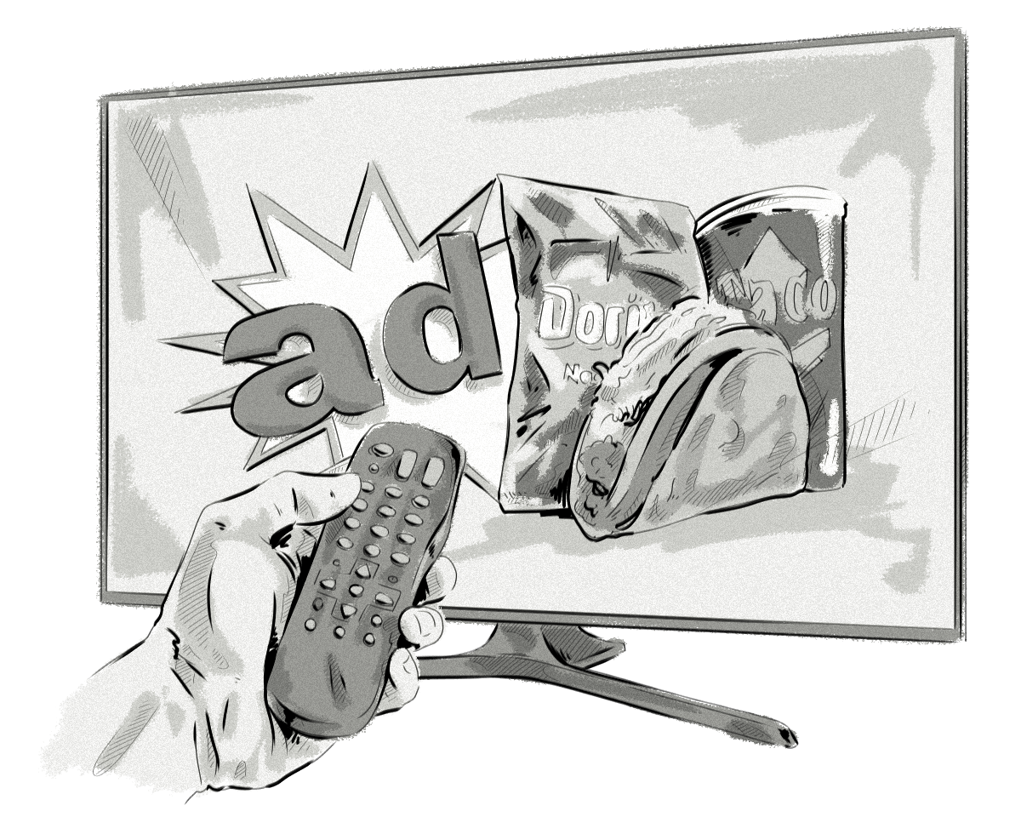**ACTIVITIES:**

* Drawing an Ad
* Drawing from Memory
* Identifying their Personal Interests
* Learning about Layouts
* Using Senses in Advertising

DIGITAL PHOTOGRAPHY

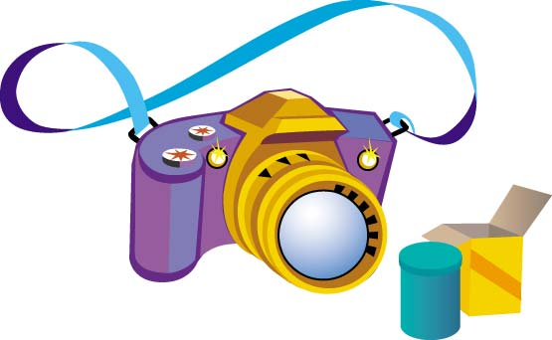**ACTIVITIES:**

* Become familiar with digital camera
* Capture Images Using a Digital Camera
* Edit, Manipulate and Enhance Photographs
* Import Photos From Camera to Computer
* Print Photographs

## GRAPHIC ARTIST

**ACTIVITIES:**



* Design a Grand Opening Flyer
* Design a Loyalty Card
* Design a Menu
* Design Logo
* Interview Customer

**FLORAL DESIGN**

**ACTIVITIES:**

* Create Corsage
* Create Simple Arrangements
* Figuring Cost
* Order Supplies
* Taking Orders

**ASSEMBLY**

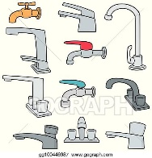

**FAUCET ASSEMBLY**

**ACTIVITIES:**

* Assemble Faucets
* Tag Faucets and put in Storage Bins
* Disassemble Faucets

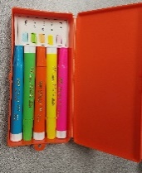**HIGHLIGHTING PEN PACKAGE  
ACTIVITIES:**

* Assemble 4 Highlighters per Box
* Place Boxes in Compartments
* Disassemble Boxes

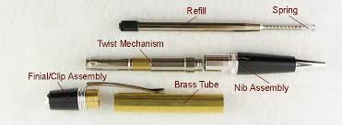**PEN ASSEMBLY**

**ACTIVITIES:**

* Assemble Pens with Refill
* Place Grip and Cap on Pen
* Assemble in Box
* Disassemble Pens

**PRECISION WEIGHING**

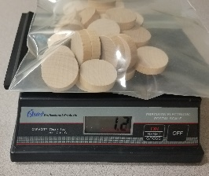**ACTIVITIES:**

* Follow Order Sheet
* Scoop Wooden Pieces to correct Weight
* Place Pieces in Storage Bag
* Figure Cost of each Order
* Disassemble Orders

**SMALL PARTS ASSEMBLY**

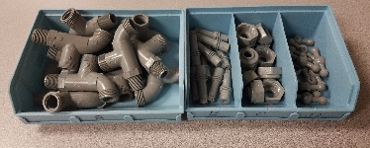**ACTIVITIES:**

* Using Direction Cards to sort Bolts, Nuts, and Washers
* Using Direction Cards to assemble Bolts, Nuts, and Washers
* Bag and Label completed Parts
* Disassemble Parts

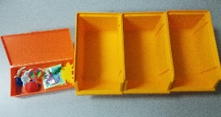**SMALL TOY PACKAGING**

**ACTIVITIES:**

* Organize Toys in Storage Bins
* Place Correct Number of Toys in each Box
* Disassemble Boxes

**MEDICAL**

## DENTAL CARE

**ACTIVITIES:**



* Labeling teeth and dental terms
* Learn about Oral Hygiene
* Making Mouth Casts
* Office Procedures and Clinical Records
* Transferring Sterile Instruments & setting up Operatory
* Using a Dental Mirror

## EMERGENCY MEDICAL TECHNICIAN

**ACTIVITIES:**

* Checking Vitals



* Immobilization Procedures
* Transporting
* Watch EMT Video
* Work with Various types of Bandages
* Wound Care

## GREENHOUSE WORK

**ACTIVITIES:**

* Greenhouse tools



* Growing Plants from Seed
* Mixing Potting Soil
* Plant diseases & insects
* Transplanting
* Testing seed for germination

#### MC900445564[1]HOME HEALTH CARE

**ACTIVITIES:**

* Changing dressing
* Dressing, grooming
* Exercise
* Laundry
* Taking Vitals

## MEDICAL PATIENT CARE



**ACTIVITIES:**

* Hand Washing
* Identify different muscles and bones
* Measuring and Recording TPR (temperature/pulse/respiration/oxygen)
* Measuring Patient Intake and Output
* Surgical aseptic techniques
* Taking a Pulse
* Taking and Recording Temperature
* Taking Blood Pressure

## MEDICAL RECORDS



**ACTIVITIES:**

* Admission to the Hospital
* Create labels
* Filing Records
* Learn Medical Terminology
* Medical Coding
* Medical Transcription

**BUSINESS/OFFICE**

# ACCOUNTING AND BOOKKEEPING

**ACTIVITIES:**

* Cash Disbursements



* Cash Receipts
* Bank Reconciliation
* Payroll

## ADMINISTRATIVE ASSISTANT

**ACTIVITIES:**

* Electronic Address Book



* Electronic Calendar
* Electronic Mailing Labels
* PowerPoint
* Preparing Formatted Letters
* Spreadsheet Project

## BANKING AND CREDIT OPERATIONS

**ACTIVITIES:**

* Balancing the Cash Drawer



* Computing Federal Estate Tax
* Preparing Bank Deposits
* Preparing a Financial Statement
* Preparing Debit/Credit Slips

## MAILING

**ACTIVITIES:**



* Collating
* Copy, scan, file mail
* Envelop stuffing
* Mail folding
* Package Wrapping and Costs Involved
* Preparing mail
* Sorting of Incoming Mail

## MANAGEMENT



**ACTIVITIES:**

* Employee scheduling
* Handling Conflict
* Hiring Employees
* Planning a Banquet, Including Reservations
* Taking Warehouse Orders

**SALES REPRESENTATIVE**



**ACTIVITIES:**

* Keeping an Expense Account
* Learn what a Sales Representative Does
* Order Forms
* Time Management and Planning
* Work on a Product Presentation

**SERVICES**

**ANIMAL CARE**

**ACTIVITIES:**

* 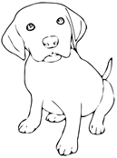 Feeding
* Grooming
* Handling Animals
* Medical Care
* Physical Exam
* Training

CHILD CARE

ACTIVITIES

* Food Handling/Preparation

Heating Bottles to Proper Temperature



Mixing Formula/Baby Cereal

Washing/Sterilizing Bottles

* Health and Safety

Bandaging

CPR

Standard/Ear Thermometer

* Measuring and Administering Medication
* Daily Activity Plans

Creative Arts Project/Making Playdough

Educational Activity

Reading Stories

* Preparing a menu

## CLEANING

**ACTIVITIES:**



* Countertops, table, sink
* Disinfecting
* Dusting
* Empty wastebaskets
* Inside Window and Mirror Cleaning
* Making Bed
* Office Cleaning
* Sweeping and Mopping
* Vacuuming

## COSMETOLOGY

**ACTIVITIES:**



* Calculating a customer’s charges



* Choosing a Hair Style for face shape, texture
* Giving a Manicure
* Making Appointments
* Styling Using Curling Iron, dryer, straightener

**CRIME SCENE INVESTIGATION (Forensics)**



**ACTIVITIES:**

* Determing foot size
* Document Analysis (comparing and contrasting various ink types)
* Fingerprint Analysis
* “How observant are you” activity
* Soil Analysis

**CULINARY**

**ACTIVITIES:**

* Convert recipe servings to accommodate a smaller or larger group
* Prepare an entrée following a recipeDescription: MC900199279[1]
* Prepare snack following a recipe
* Proper clean up concerning food and dishes
* Proper hand washing and surface cleaning procedures

**FOOD SERVICE (New 2020)**

**ACTIVITIES:**

* Become familiar with safety tips
* Clean table
* Dealing with complaints
* Dishwashing
* Prepare food
* Serve food
* Set table

## GROCERY CLERKING

**ACTIVITIES:**



* Bagging Groceries
* Building a Grocery Display
* Check stand Procedures
* Checking for expired items
* Cleaning & stocking Shelves
* Take out Procedures Checking out

#### LAW ENFORCEMENT

**ACTIVITIES:**



* Accident Investigation
* Crime Scene report
* Fingerprinting
* Handwriting comparison
* Plaster Cast Foot Print

## WAITER/WAITRESS

**ACTIVITIES:**



* Busing of Table after Meal Setting a table
* Calculate Customers Bill
* Completing miscellaneous activities
* Give Customer Proper Change
* Serving Meals to Customer
* Taking Customer Orders

**TRADE AND INDUSTRY**

**AGRICULTURE (CROPS)**

**ACTIVITIES:**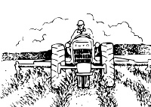

* Bookkeeping
* GPS
* Diseases and Pests
* Maintenance
* Production Costs
* Soil Testing
* Yield

AUTO SERVICE MECHANIC

**ACTIVITIES:**

* Changing a Tire



* Check the Oil Level in an Engine
* Remove and Replace Heater and Radiator Hoses
* Remove and Replace a Thermostat
* Remove Water Inlet Housing
* Replace a Gasket
* Testing a Battery
* Understand the Purpose of Coolants and Antifreeze
* Using a Jack

###### CARPENTRY

###### Description: drillACTIVITIES:

* Identify and Sort Fasteners
* Identify Woods
* Make a Birdhouse
* Measuring
* Operate Power Hand Drill & Screwdriver
* Read a Blueprint
* Use Screws and Nails

ELECTRICITY

**ACTIVITIES:**

* Hook up the Following Circuits:



1. Light Switch to Control Plug in Receptacle
2. Plug in Receptacle
3. Pull-string Light
4. Read electrical plan
5. Use voltage tester

**FLUID POWER**

**ACTIVITIES:**

* Ball Thrower
* Build Horizontal Lifter
* Fluid System
* Hydraulic Safety
* Pneumatics
* Service Order
* Solving problems-Hydraulics

## PLUMBING

**ACTIVITIES:**

* Connect Finish Fittings
* Disassemble/Inspect Faucet



* Install Drains
* Install Gas Line
* Install Hoses
* Install Water Supply Lines
* Plumbing invoice
* Reassemble Faucet

## SMALL ENGINE REPAIR

**ACTIVITIES:**



* Calculate Costs for Work Order and Present to the Customer
* Disassemble a Small Engine
* Examine Working Parts of a 4-Cycle Engine
* Fill Out a Work Order
* Learn Proper Use of a Torque Wrench
* Re-assemble Engine

## TRUCKING

**ACTIVITIES:**

* Backing Up
* Become familiar with Bill of Lading
* Handle materials & materials “load dock” worksheet



* Planning a Trip
* Using mapping on computer
* Securing a Ratchet Strap
* Uniform Straight Bill of Lading
* Using the Motor Carrier Safety Regulations Book
* Watch Pre-Trip Inspection Video

## WIND ENERGY

**ACTIVITIES:**

* Build Wind Tower
* Choose correct blades and insert
* MC900056887[1] Crimp wires
* Learn wind energy terminology
* Install harness
* Power Light Bulb
* Test Voltage with multi-meter
* Wind power math calculations